Software Requirements and Design (SRD)
Project Title: PixelPals
Module: CS2TP Team Project
Date: 19.10.2025
Version: Draft 2.0

Table of Contents
Contents
1. Team Information 2
1.1 Team Members and Roles 2
1.2 Belbin Roles 2
1.3 Team Logo and Identity 2
2. Project Description 3
2.1 Project Overview 3
2.2 Vision and Objectives 3
2.3 Target Audience 3
2.4 Technologies and Tools 3
3. Functional Requirements 3
3.1 Introduction 3
3.2 Requirement List (FR1–FR5) 3
4. Non-Functional Requirements 4
4.1 Performance 4
4.2 Security 4
4.3 Usability and Accessibility 4
4.4 Maintainability 4
5. Use Cases and Design 4
5.1 Use Case Diagram (optional) 4
5.2 Use Cases – Products 4
5.3 Use Cases – Login & Basket 4
5.4 Interface Wireframes 4
5.5 Database Design (ERD) 4
5.6 Flow Diagrams (Admin/User Journey) 4
5.7 Site Map 4
6. Project Management 5
6.1 Development Methodology 5
6.2 Project Planning Tools (Trello) 5
6.3 Communication and Collaboration 5
6.4 Version Control and File Management (GitHub) 5
6.5 Design and Technical Overview 5
6.6 Team Section Responsibilities 5
7. Conclusion 6
Appendices 6
Appendix A – Entity Relationship Diagram 6
Appendix B – Admin Flow Diagram 6
Appendix C – Wireframes and Brand Design 6
Appendix D – User Journey Diagram 6
Appendix E – Product Grid (optional) 6
Appendix F – Site Map 6

(Right-click → Update Field → Update Entire Table once complete)

1. Team Information

1.1 Team Members and Roles
List each team member, their role, and main responsibility.

1.2 Belbin Roles
Identify each member’s Belbin role and how it supports the team.

1.3 Team Logo and Identity
Insert logo image here and describe colour scheme / brand identity.

2. Project Description

2.1 Project Overview
Briefly describe what your project is about, its purpose, and context.

2.2 Vision and Objectives
Write a short statement outlining your overall goal and measurable objectives.

2.3 Target Audience
Describe who your product is for (e.g. children, parents, accessible users).

2.4 Technologies and Tools
PixelPals is going to use certain technologies and tools for the current design stage and for future development of the system.
Category | Technology and Tools used/planned | Purpose
Backend development | Laravel (PHP), MySQL | Will be used to make user accounts, product data and parental controls.
Frontend development | HTML, CSS, JavaScript | Will be used to make the website interface and for browsing and selecting products.
UI/UX design | Figma, Canva | Used to create layout, logo and accessibility structure.
Version Control | GitHub | Used to store project work and control changes by using pull requests and commits.
Project Management | Trello, Discord | Trello is used to assign and track tasks with deadlines. Discord is used for team communication.
Documentation | Microsoft Word | Used to make and update the Software requirements design report.

3. Functional Requirements

3.1 Introduction
Functional Requirements is based on what the system should do, This can done by the usage of features, specific actions, and behaviours so that it helps the user throughout the website. For the PixelPals Project, Function Requirements will make sure that system functionally will allow the users to register, sign in, placing orders and adding Parent control. Furthermore, Function Requirements will support both users and admins by providing features to manage and interact with the ecommerce website with ease .

3.2 Requirement List (FR1–FR5)
List and describe each functional requirement (FR1, FR2, etc.).
5. The System will allow admins to manage and view products
The systems should allow the user to view their basket and make changes to their basket such as increasing or decreasing the quantity of an item. The system shouldn’t allow the user shouldn’t be able to order a negative quantity of an item. The changes made to a user’s basket should be updated in the database.
6. The System will allow the users to update their personal information
The system should allow the user to change personal information such as phone number, email address, home address, etc. The system will override the previous information and update the changes made by the user.

4. Non-Functional Requirements

4.1 Performance
State any speed, responsiveness, or load time requirements.
The website must be able to load quickly, especially the main page as it’ll prevent the users from leaving the website.
The website should respond very quickly when users interact with elements such as buttons to prevent any frustration. The responsiveness of the website will be measured with the Interaction to Next Paint (INP) which is an industry standard for measuring the responsiveness of a website.
Boosting perceived performance is another way to make the website seem more responsive to achieve this we should ensure that user receives immediate visual feedback for example a button changing colour when clicked or showing a loading icon so that they are aware that their action has been registered and that the website is processing it which will therefore reduce the perceived processing/loading time.

4.2 Security
Technical Security:
In order to protect user data we’ll implement a Hypertext Transfer Protocol Secure(HTTPS) by using a valid TLS certificate in order to encrypt data sent between the browser and the website to prevent man-in-the-middle attacks.
We’ll also implement simple but strong password policies like:
- Password must have a minimum of 8 characters and it must include an uppercase letter, lowercase letter and a number or special character
- Old passwords can’t be reused
- Passwords can't be shared and if someone finds out the password it must be changed
This will help kids understand the importance of privacy.
Parental Control and Data Privacy:
The PixelPals website is designed for children and parents, which means data protection must be prioritised at every stage of development. To achieve this, the system will include parental control features and account security to support safe and responsible use.

Security requirement | Planned implementation
Child data privacy | Only essential user data will be collected, and the data will be stored securely in the database.
Parental control access | Parents will have access to screen time rules for children.
Password security | Passwords will be hidden and will have minimum length rules, so they cannot be easily guessed.
Access permissions | Only authorised members can change or update product information.

Overall, these measures will keep the system suitable for children while giving parents reassurance and control over their child’s digital wellbeing.

4.3 Usability and Accessibility
Describe how your design accommodates different users and devices.

4.4 Maintainability
Documentation and structure:
The PixelPals system is designed to be easy to update and expand in the future. The team has used organised and traceable development practices to support all continuous improvements.
Maintainability principle | Application in PixelPals
Clear folder structure | Creating organised files that are easy to locate, such as SRD, Drafts, Evidence and Docs files on GitHub.
Version control best practice | Team members will be their own branches on GitHub and use pull requests to the main area to avoid conflicts and track changes early.
Continuous documentation | All meeting notes, commit summaries and report document versions will be recorded throughout development.
Modular design approach | Frontend and Backend components will be built in small functional parts for easier updates and fixes.

To summarise, all these approaches will support long-term maintenance by allowing new features and bug fixes to be added without difficulty.

5. Use Cases and Design

5.1 Use Case Diagram (optional)
Insert your use case diagram or describe it.

5.2 Use Cases – Products
Describe product browsing, searching, and filtering features.

5.3 Use Cases – Login & Basket
Describe login, account, and basket management features.

5.4 Interface Wireframes
Insert screenshots or sketches of your interface design.

5.5 Database Design (ERD)
Insert your ERD diagram and explain relationships between tables.

5.6 Flow Diagrams (Admin/User Journey)
Insert admin or user journey flow diagram.
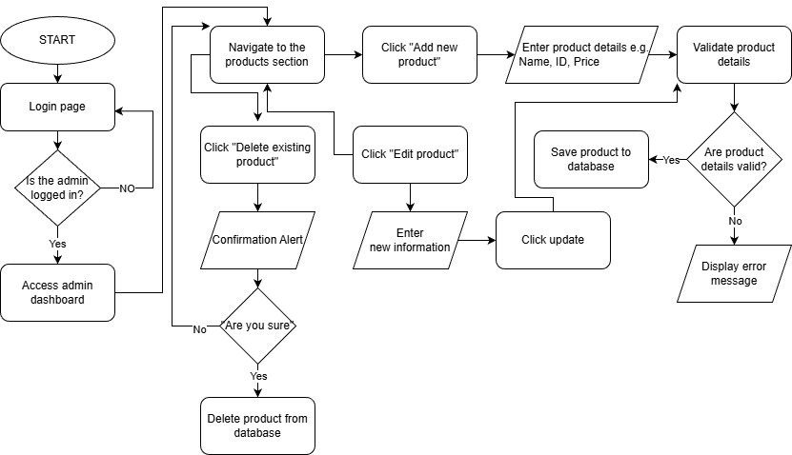

5.7 Site Map
This section presents the PixelPals website site map, illustrating the complete navigation structure. It highlights how users move between pages such as Home, Products, Basket, and Account. Each branch represents a major user flow or feature area.
Home
├── Products
│ ├── Categories
│ └── Product Detail
├── Basket
├── Account
│ ├── Login / Register
│ └── Profile & Orders
└── Admin (protected area)
This hierarchy demonstrates how users will navigate through the application. The final visual site map diagram is included in Appendix F.

6. Project Management

6.1 Development Methodology
Explain the methodology used (Agile/Scrum) and why it was chosen.

6.2 Project Planning Tools (Trello)
Include link/screenshot of your Trello board and describe how it was used.

6.3 Communication and Collaboration
Describe how your team communicated (e.g., Discord, in-person meetings).

6.4 Version Control and File Management (GitHub)
Include your GitHub repository link and discuss how you managed versions.

6.5 Design and Technical Overview
Summarise key design or technical decisions.

6.6 Team Section Responsibilities
The following table details which team member is responsible for each SRD section.
Section No. | Section Title | Assigned Member(s)

7. Conclusion

Appendices

Appendix A – Entity Relationship Diagram
Insert ERD diagram here.

Appendix B – Admin Flow Diagram
Insert admin flow diagram here.


Appendix C – Wireframes and Brand Design
Insert wireframe images and brand colours/fonts here.

Appendix D – User Journey Diagram
Insert user journey diagram here.

Appendix E – Product Grid (optional)
Insert product grid design or screenshots here.

Appendix F – Site Map
Insert your final site map diagram (image or exported screenshot from Figma or Draw.io). Reference this appendix in Section 5.7.

